Improve Diagnostic Accuracy for Coronary Disease:
Begin with the Assays
Faye Walker, Ph.D.

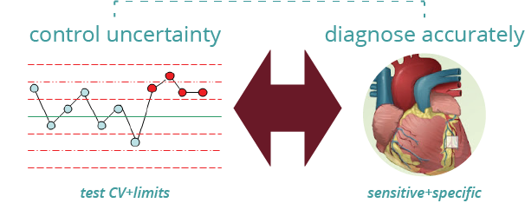
Chest pain. Shortness of breath. Vomiting. What do these three things have in common? All are symptoms of coronary artery disease.
Premature deaths from coronary heart disease are largely attributable to acute myocardial infarction (AMI). Nearly 18 million lives were claimed by cardiovascular diseases in 2019; of these, 85% were due to AMI and ischemic stroke (WHO, 2021).
There is a silver lining. Cardiovascular disease is largely preventable with the proper intervention of public health services. Initial treatment of heart failure, hypertension, and AMI have all aided in the steady decline of mortality rates in first-world countries since the 1980s (Mendis, Puska, & Norrving, 2011).
However, procuring accurate test results requires careful attention to detail. From laboratory instrument monitoring to patient sampling protocols, clinicians and physicians all play a role in making accurate diagnostic decisions.

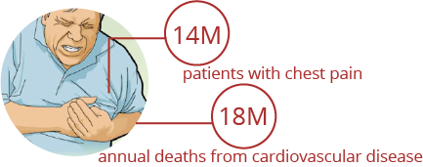
The world’s biggest killer
In a single year, over 14 million patients present with complaints of ischemic chest pain in the emergency department (NCHS, 2018). If AMI is misdiagnosed, patients could face costly, time-consuming, and invasive investigations—all of them futile.
Cardiac biomarkers are used to diagnose patients with suspected AMI. When heart muscles are damaged as a result of a heart attack, the body releases a plethora of cardiac enzymes. Myoglobin, creatine kinase, and troponin are just a few of the indicators that have historically signaled ischemic events (Tilea, Varga, & Serban, 2021). The American College of Cardiology (ACC) has recommended cardiac troponin for the diagnosis of AMI due to its superior sensitivity and accuracy (Schreiber, 2018).

The advent of high-sensitivity assays
In 1989, the first-generation immunoassay to measure troponin was introduced. Its automatization for clinical use faced two problems: false positives from nonspecificity, plus long turnarounds that lasted up to 90 minutes (Oliveira, Glasgow, & al., 2018).
As time progressed, troponin assays became increasingly rapid and sensitive. Today’s fifth-generation assays emphasize the clinical role of cardiac troponin. These high-sensitivity troponin assays promise more accurate, rapid evaluation of patients for fewer misclassifications and safer discharges.

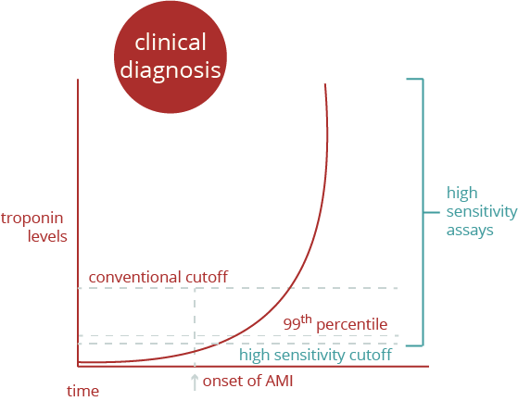
The challenges of implementation
This improvement in sensitivity does come at a cost. The analytic imprecision of an assay, or coefficient of variation (CV), typically increases with decreasing analyte concentration. Ideally, the clinical assays used to measure troponin should have a CV below 10% at the relevant level (Schreiber, 2018).
Defining those levels is a problem unto itself. The European Society of Cardiology (ESC) and the ACC have recommended that a positive, high-risk troponin result be above the 99th percentile for a healthy patient population (ESC, 2000). But this range may not capture patients with slightly lower levels who still exhibit an elevated cardiac risk. Even worse, most troponin assays are imprecise at this reference limit.

Cutting-edge techniques to determine cutoffs
How can clinical labs improve the diagnostic accuracy of AMI? One key factor is recognizing that the observed cutoff of a 10% CV will vary between platforms. The particularities of each troponin assay will determine whether this cutoff can safely be used to exclude a diagnosis of AMI.
The decision points determining high-risk and low-risk patients need to be robust against reagent changes, platform variability, and instrument maintenance. Internal quality control materials help monitor system performance. Moreover, the application of controls impacts how patient samples are evaluated. A twice-daily evaluation of quality materials near the limit of detection of highly sensitive troponin assays has been shown to improve diagnostic accuracy for AMI (Aloisio, Pasqualetti, & al., 2020).

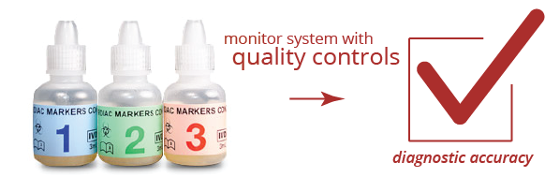
Daily monitoring for quality decision-making
Daily testing is imperative to help standardize results between different testing sites that are equipped with their individual reagent formulations, lots, and instrumentations. In a recent study on troponin cutoff levels for AMI rule-out, patient samples were collected from 14 geographically diverse, hospital-associated emergency departments. They were then submitted to three independent clinical laboratories for analysis on the Access hsTnI DxI 800 immunoassay system (Beckman Coulter, Inc., Brea, CA) (Peacock, Christenson, & al., 2020).
How could the authors ensure that the various plasma samples would be correctly interpreted at each site? As it turned out, they had previously established a method for biomarker testing utilizing More Diagnostics’ Cardiac Markers Control (Los Osos, CA). From the 14 sites of emergency departments, patient samples were sent to four independent external laboratories. Personnel at each laboratory reported the actual CVs of Beckman Coulter’s Access AccuTnI+3 assay (Brea, CA) by running Bio-Rad’s quality controls (Hercules, CA) and the Cardiac Markers Control (More Diagnostics Inc., Los Osos, CA) twice per day, in duplicate (Storrow, Christenson, & al., 2015).
After validating the AccuTnI+3, analysis on the patient cohort could predict AMI with nearly 90% probability based on levels of troponin that rose above a set diagnostic threshold (Storrow, Christenson, & al., 2015).

Rapidly ruling out a diagnosis
The 2020 follow-up to this result addressed a different question: whether patients could be safely excluded from a diagnosis of AMI. A successful rule-out benefits both the emergency department and the patient by increasing diagnostic accuracy and providing peace of mind.
The authors were 100% accurate in excluding AMI in patients with suspected acute coronary syndromes. Their findings showed that troponin levels stayed below the 10% or 20% assay CV cutoffs for those who truly did not have the disease. The increased sensitivity of Beckman Coulter’s hsTnI assay (Brea, CA) is what made the investigation possible. Going further, the results on this high sensitivity assay could be used for an accelerated diagnosis (<6 hours) that only required sampling at 2 timepoints: upon admission and after three hours (Peacock, Christenson, & al., 2020).

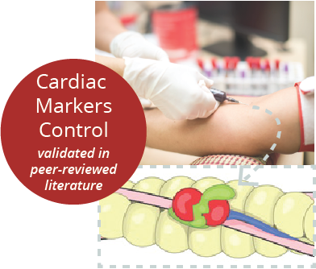
Towards a more assured future
Improvements in the analytical sensitivity of clinically available assays have enabled safer discharge rates and admissions in emergency departments. With the advent of new techniques, emergency departments are identifying patients at high risk for adverse cardiac events in shorter time frames based on elevated troponin levels.
Further research is needed to discover a truly ideal biomarker for rapid and reliable AMI diagnosis and management. The increased sensitivity in modern troponin assays provides valuable information—at the cost of specificity. Nearly two-thirds of patients with high-risk troponin levels do not have AMI (Tilea, Varga, & Serban, 2021).
A combination of biomarkers can paint a more complete picture about the physiological nature of myocardial stress. Multi-biomarker assessment, based on disease pathology, follows a variety of mechanisms to relay the nature and scope of damage to the heart. For example, the Cardiac Markers Control used by Storrow et al. (More Diagnostics, Inc., Los Osos, CA) contains a total of four proteins (myoglobin, CKMB, CRP, in addition to cardiac troponin). These are in turn dosed at three clinically relevant levels that correlate with the progression of AMI.

Keeping on top of analytical results
Managing patients by their blood levels does have several caveats for implementation. In practice, laboratories need to be mindful of the precision and sensitivity of their particular systems. This is evidenced by the importance of reporting the CV of any assay, including those that identify low-level changes in troponin.
Every second counts when it comes to coronary artery disease. Symptomatic patients gain admittance when they are in the late stages of disease and intervention is crucial. Introducing the optimal quality tools, diagnostic thresholds, and patient sampling protocols can make the difference between ruling-in or -out AMI in an emergency department—and saving a life.

References
Aloisio, E., Pasqualetti, S., & al. (2020). Daily Monitoring of a Control Material with a Concentration Near the Limit of Detection Improves the Measurement Accuracy of Highly Sensitive Troponin Assays. Clinical Chemistry and Laboratory Medicine, 29-31.
ESC. (2000). Myocardial Infarction Redefined—A Consensus Document of The Joint European Society of Cardiology/American College of Cardiology Committee for the Redefinition of Myocardial Infarction. European Heart Journal, 1502-1513.
Mendis, S., Puska, P., & Norrving, B. G. (2011). Global Atlas on Cardiovascular Disease Prevention and Control. Geneva, Switzerland: World Health Organization.
NCHS. (2018). National Center for Health Statistics: National Hospital Ambulatory Medical Care Survey. Centers for Disease Control and Prevention.
Oliveira, A., Glasgow, K., & al. (2018). Acute Myocardial Infarction: Definition, Diagnosis, and the Evolution of Cardiac Markers. Clinical Laboratory Science, 1-16.
Peacock, W. F., Christenson, R., & al. (2020). Myocardial Infarction Can Be Safely Excluded by High-sensitivity Troponin I Testing 3 Hours After Emergency Department Presentation. Academic Emergency Medicine, 671-680.
Schreiber, D. (2018). Cardiac Markers. Medscape.
Storrow, A. B., Christenson, R. H., & al. (2015). Diagnostic Performance of Cardiac Troponin I for Early Rule-in and Rule-out of Acute Myocardial Infarction: Results of a Prospective Multicenter Trial. Clinical Biochemistry, 254-259.
Tilea, I., Varga, A., & Serban, R. (2021). Past, Present, and Future of Blood Biomarkers for the Diagnosis of Acute Myocardial Infarction--Promises and Challenges. Diagnostics, 1-19.
WHO. (2021). Cardiovascular Diseases (CVDs). Retrieved from World Health Organization: https://www.who.int/en/news-room/fact-sheets/detail/cardiovascular-diseases-(cvds)

